DDPAI השיקה את סדרת Z90 בריאד: "נולדה להוביל" מגדירה סטנדרט חדש במצלמות דשבורד חכמות
ריאד, ערב הסעודית, 6 בנובמבר 2025 (GLOBE NEWSWIRE) –
DDPAI השיקה רשמית את סדרת הדגל שלה Z90 והציגה את ה-N5 Pro החדשה בכפר אל אמאריה בריאד תחת הנושא "נולדה להוביל". האירוע בהשראת המדבר הפגיש מפיצים מקומיים, נציגי תקשורת ושותפים בתעשייה לתצוגה סוחפת ששילבה טכנולוגיה מתקדמת עם רוח התרבות הסעודית.

DDPAI Launches the Z90 Series in Riyadh: “Born to Lead” Defines a New Standard in Smart Dashcams

DDPAI Celebrates "Born to Lead" Launch Event in Riyadh
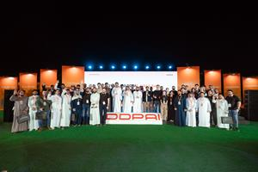

The DDPAI team, partners, and distinguished guests gather for a commemorative group photo at the Al AMAARIA Village in Riyadh. The event, held under the theme “Born to Lead,” marked the successful official launch of the brand's flagship Z90 Series.

The New Flagship: DDPAI Z90 Master
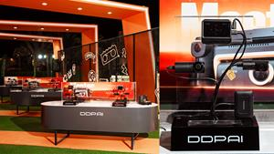

A detailed studio shot of the new flagship DDPAI Z90 Master, a centerpiece of the “Born to Lead” launch event. The dash cam is featured on a rotating display, highlighting its premium metallic finish and carbon fiber details, with its official retail packaging visible in the background.

DDPAI Z90 Series and N5 Pro Showcase
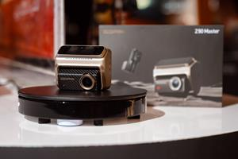

The immersive DDPAI product showcase at the Al AMAARIA Village in Riyadh. The elegantly designed booth, illuminated against the night sky, features the complete newly launched lineup, including the flagship Z90 Series (like the new Desert version), allowing guests to experience the "Born to Lead" technology first-hand.
RIYADH, Saudi Arabia, Nov. 06, 2025 (GLOBE NEWSWIRE) –
DDPAI officially launched its flagship Z90 Series and showcased the new N5 Pro at Al AMAARIA Village in Riyadh under the theme “Born to Lead.” The desert-inspired event brought together local distributors, media representatives, and industry partners for an immersive showcase that combined advanced technology with the spirit of Saudi culture.
At the heart of the Z90 Series is an industry-leading triple-channel imaging system, featuring dual 4K front and rear recording and a 3K in-cabin camera with AI portrait enhancement and infrared night vision. Together, they deliver full-scene clarity both inside and outside the vehicle, setting a new benchmark for visual safety on the road.
Built on DDPAI’s proprietary πLink technology, the Z90 achieves Full-Digital transmission across all channels, ensuring lossless image quality and ultra-stable connectivity. With 4G connectivity, users can remotely view footage, receive real-time alerts, and enjoy always-on protection, even when away from the car.
Alongside the flagship model, DDPAI introduced the N5 Pro, an upgraded version of the brand’s best-selling 4G dual-camera dashcam. Designed for drivers who seek dependable daily performance, the N5 Pro delivers 4K front + 2K rear recording, expanded built-in eMMC storage, and upgraded Wi-Fi 6 connectivity, making premium imaging and effortless sharing accessible to a wider audience.
Adding to the excitement, DDPAI also unveiled the Z90 Master – Desert Edition, a limited-edition model inspired by the endless dunes of Arabia. With its golden metallic shell and a carbon-fiber-textured front, the design pays tribute to the resilience and elegance of the desert, blending advanced engineering with local artistry.
“The Z90 Series represents more than just a hardware upgrade,” said a DDPAI spokesperson during the event. “It reflects our belief that technology and culture can coexist — delivering not only innovation, but also a deeper connection between people, cars, and the journeys they share.”
The launch of the Z90 Series and the preview of N5 Pro marks another milestone in DDPAI’s expansion across the Middle East, following a series of successful market campaigns in Saudi Arabia and beyond. With a commitment to smarter, safer, and more connected driving, DDPAI continues to lead the global evolution of intelligent automotive imaging technology.
Contact
marketing@ddpai.com
Photos accompanying this announcement is available at
https://www.globenewswire.com/NewsRoom/AttachmentNg/9dfe9584-7f64-4469-a578-975dffe63c9d
https://www.globenewswire.com/NewsRoom/AttachmentNg/aa190a9a-e8a0-4e16-88c8-b45bef9b79fe
https://www.globenewswire.com/NewsRoom/AttachmentNg/e1959834-4093-4b8b-88a4-1eb86b17b290
*** הידיעה מופצת בעולם על ידי חברת התקשורת הבינלאומית GlobeNewswire
לפרטים נוספים: נוי תקשורת 03-6026026 זהר 052-2641769

